Lab 4
CART REGRESSION
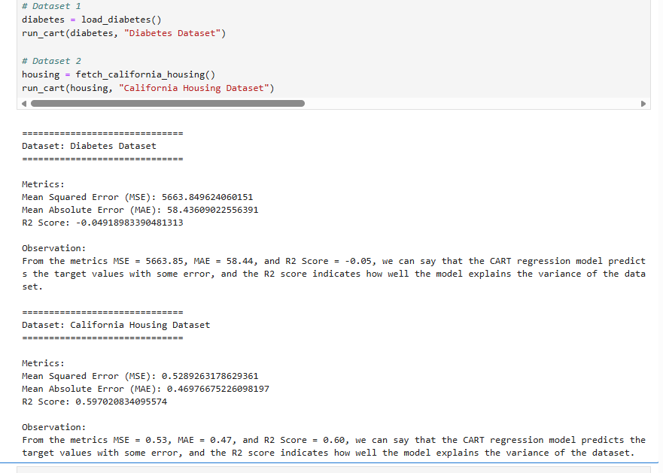

ID3
import pandas as pd
from sklearn.datasets import load_iris, load_wine
from sklearn.model_selection import train_test_split
from sklearn.tree import DecisionTreeClassifier, export_text
from sklearn.metrics import accuracy_score, confusion_matrix, classification_report

# ================= IRIS DATASET =================
print("\n==============================")
print("Dataset: IRIS Dataset")
print("==============================")

iris = load_iris()
df_iris = pd.DataFrame(iris.data, columns=iris.feature_names)
df_iris['Target'] = iris.target

print("\nFirst 5 rows of dataset:\n")
print(df_iris.head())

X = df_iris.drop('Target', axis=1)
y = df_iris['Target']

X_train, X_test, y_train, y_test = train_test_split(X, y, test_size=0.3, random_state=42)

model = DecisionTreeClassifier(criterion='entropy') # ID3 uses entropy
model.fit(X_train, y_train)

y_pred = model.predict(X_test)

print("\nAccuracy:\n", accuracy_score(y_test, y_pred))
print("\nConfusion Matrix:\n", confusion_matrix(y_test, y_pred))
print("\nClassification Report:\n", classification_report(y_test, y_pred))

print("\nDecision Tree Rules:\n")
tree_rules = export_text(model, feature_names=list(X.columns))
print(tree_rules)

# ================= WINE DATASET =================
print("\n==============================")
print("Dataset: WINE Dataset")
print("==============================")

wine = load_wine()
df_wine = pd.DataFrame(wine.data, columns=wine.feature_names)
df_wine['Target'] = wine.target

print("\nFirst 5 rows of dataset:\n")
print(df_wine.head())

X = df_wine.drop('Target', axis=1)
y = df_wine['Target']

X_train, X_test, y_train, y_test = train_test_split(X, y, test_size=0.3, random_state=42)

model = DecisionTreeClassifier(criterion='entropy') # ID3
model.fit(X_train, y_train)

y_pred = model.predict(X_test)

print("\nAccuracy:\n", accuracy_score(y_test, y_pred))
print("\nConfusion Matrix:\n", confusion_matrix(y_test, y_pred))
print("\nClassification Report:\n", classification_report(y_test, y_pred))

print("\nDecision Tree Rules:\n")
tree_rules = export_text(model, feature_names=list(X.columns))
print(tree_rules) import pandas as pd
from sklearn.datasets import load_iris, load_wine
from sklearn.model_selection import train_test_split
from sklearn.tree import DecisionTreeClassifier, export_text
from sklearn.metrics import accuracy_score, confusion_matrix, classification_report

# ================= IRIS DATASET =================
print("\n==============================")
print("Dataset: IRIS Dataset")
print("==============================")

iris = load_iris()
df_iris = pd.DataFrame(iris.data, columns=iris.feature_names)
df_iris['Target'] = iris.target

print("\nFirst 5 rows of dataset:\n")
print(df_iris.head())

X = df_iris.drop('Target', axis=1)
y = df_iris['Target']

X_train, X_test, y_train, y_test = train_test_split(X, y, test_size=0.3, random_state=42)

model = DecisionTreeClassifier(criterion='entropy') # ID3 uses entropy
model.fit(X_train, y_train)

y_pred = model.predict(X_test)

print("\nAccuracy:\n", accuracy_score(y_test, y_pred))
print("\nConfusion Matrix:\n", confusion_matrix(y_test, y_pred))
print("\nClassification Report:\n", classification_report(y_test, y_pred))

print("\nDecision Tree Rules:\n")
tree_rules = export_text(model, feature_names=list(X.columns))
print(tree_rules)

# ================= WINE DATASET =================
print("\n==============================")
print("Dataset: WINE Dataset")
print("==============================")

wine = load_wine()
df_wine = pd.DataFrame(wine.data, columns=wine.feature_names)
df_wine['Target'] = wine.target

print("\nFirst 5 rows of dataset:\n")
print(df_wine.head())

X = df_wine.drop('Target', axis=1)
y = df_wine['Target']

X_train, X_test, y_train, y_test = train_test_split(X, y, test_size=0.3, random_state=42)

model = DecisionTreeClassifier(criterion='entropy') # ID3
model.fit(X_train, y_train)

y_pred = model.predict(X_test)

print("\nAccuracy:\n", accuracy_score(y_test, y_pred))
print("\nConfusion Matrix:\n", confusion_matrix(y_test, y_pred))
print("\nClassification Report:\n", classification_report(y_test, y_pred))

print("\nDecision Tree Rules:\n")
tree_rules = export_text(model, feature_names=list(X.columns))
print(tree_rules)
